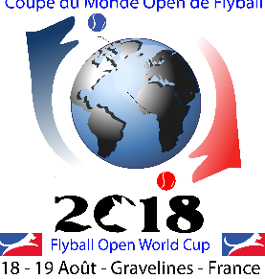
FOWC 2018 MIDDAY MEAL RESERVATION FORM

*********************************************

SELF-SERVICE MEAL AT THE ESPACE GOURMAND CAFETERIA

13.00 € / Person / Meal consisting of

STARTER – DISH – DESSERT and ¼ liter drink of your choice

NOM PRENOM
RESERVES SELF-SERVICE MEALS THURSDAY 16 August 2018 midday Number of meals x 13.00 € = €
FRIDAY 17 August 2018 midday Number of meals x 13.00 € = € SATURDAY 18 August 2018 midday Number of meals x 13.00 € = €
SUNDAY 19 August midday Number of meals x 13.00 € = €
Only persons having reserved their meals will be able to enter the cafeteria.
Total order : X meals x 13.00 € = €
Reservation with payment to be sent at the latest by Monday 13th August 2018 to
Madame Anne PEUPLE 25 RUE VAUBAN 59430 SAINT POL SUR MER
France
EMAIL ADDRESS FOR INFORMATION: annepeuple@sfr.fr

OUR BANK ACCOUNT DETAILS
Account holder : FOWC Coupe du Monde Flyball 2018
Bank : Crédit Mutuel Nord Europe
Branch : CCM Dunkerque Centre
IBAN : FR76 1562 9027 0200 0298 6050 343 BIC (SWIFT): CMCIFR2A

